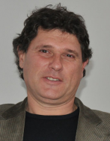
Tomaž Pavlin, PhD
Assistant professor
University of Ljubljana
Faculty of sport

Subjects

• Anthropology of sport
• Social contexts of kinesiology
• Kinesiology in poly-structured conventional sports
• History of sports

